Mini Project Report

On

**ONLINE SHOPPING SYSTEM**

***Submitted By:***

**Nisharga Mridha (010), Junayed Bin Islam (006),**

**Nazia Zaman (016)**

**Group ID: 06**

**Session: Summer 2020**

***Submitted to:***

**Dr.Ahmed Wasif Reza**

**Associate professor at East West University**

**Date: September 24th, 2020**

**East West University**

**1212 - Dhaka, Bangladesh**

**Department of Computer Science and Engineering**

**INTRODUCTION**

This project is a web-based shopping system for an existing shop. Online shopping is the process whereby consumers directly buy goods or services from a seller in real-time, without an intermediary service, over the Internet. It is a form of electronic commerce. This project is an attempt to provide the advantages of online shopping to customers of a real shop. It helps to buy the products in the shop anywhere through the internet. Thus the customer will get the service of online shopping and home delivery from his favorite shop

**SYSTEM DESIGN**

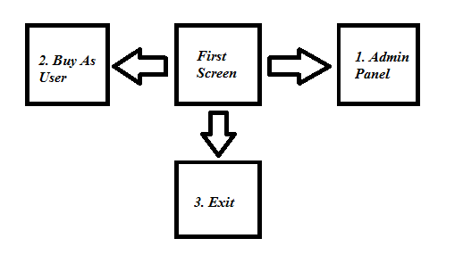

Fig 1.1: First Screem

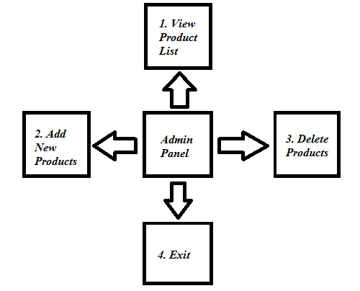

Fig 1.2: Admin Panel

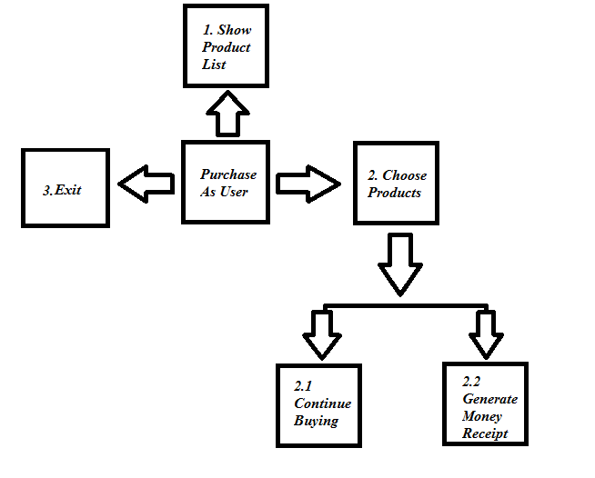

Fig 1.3: Purchase as User

#### 

#### 

**DIAGRAM**

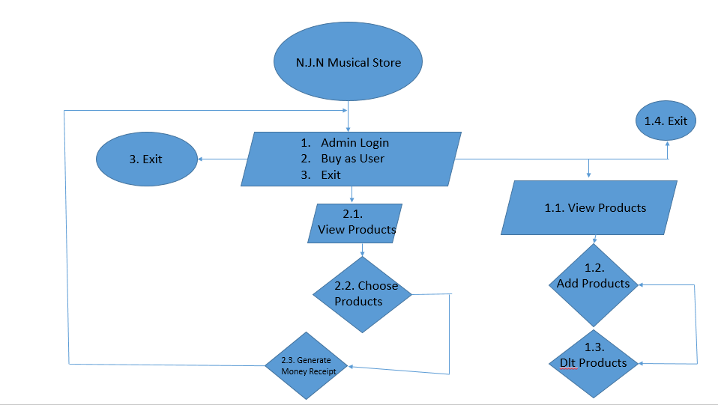

Fig 1.4: Diagram

PROGRAM OUTPUT

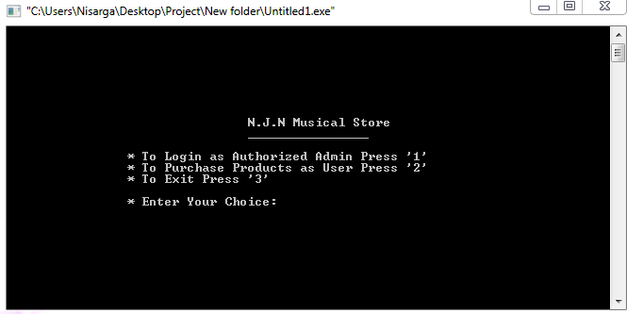

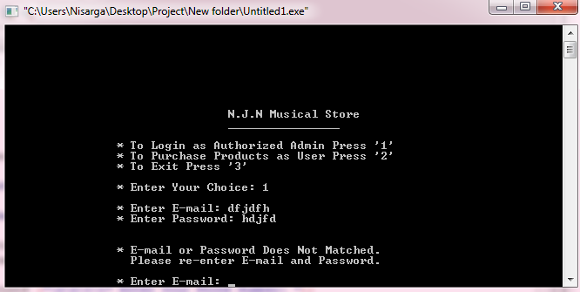

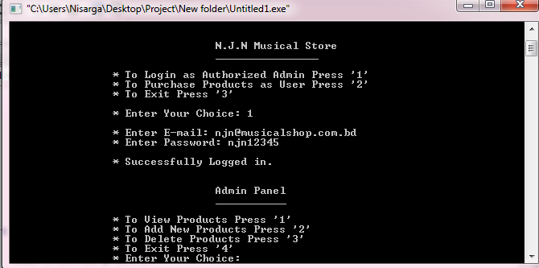

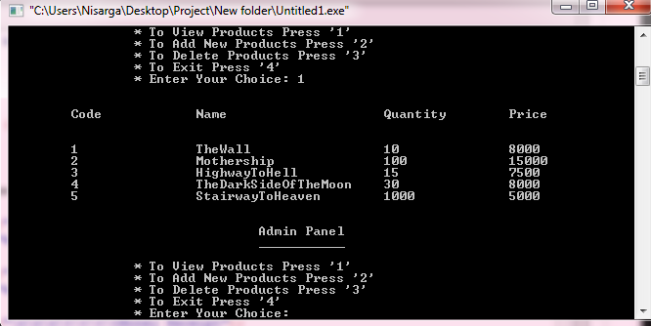

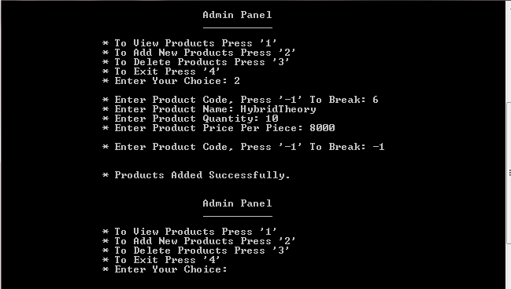

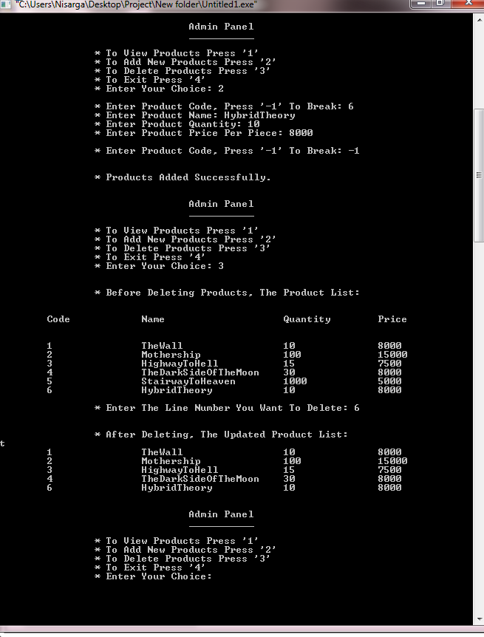

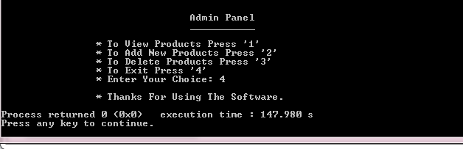

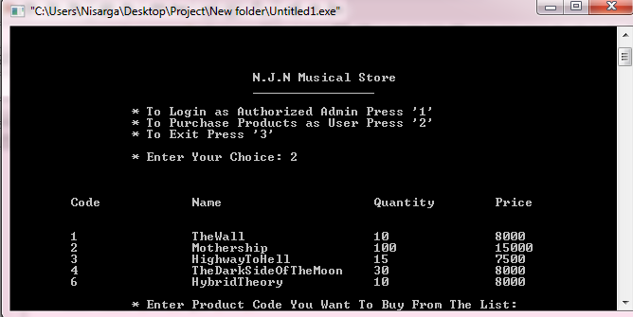

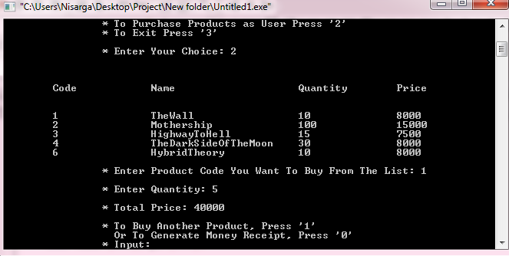

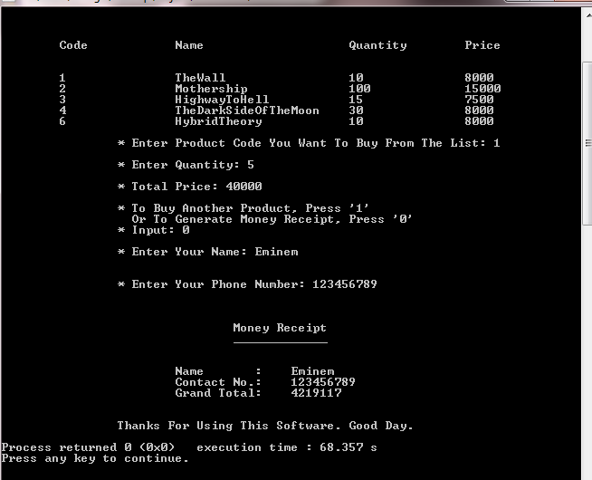

LIMITATIONS

1. Using this program, a user cannot choose multiple products at the same time. The program only works for generating a receipt for only one product at a time.
2. After purchasing, the quantity of products remains the same instead of decreasing in this program.

APPENDIX

#include <stdio.h>

#include <string.h>

int first_screen () {

char in;

printf ("\n\t\t* To Login as Authorized Admin Press '1'");

printf ("\n\t\t* To Purchase Products as User Press '2'");

printf ("\n\t\t* To Exit Press '3'");

printf ("\n\n\t\t* Enter Your Choice: ");

scanf ("%i", &in);

printf ("\n");

if (in == 1) {

login ();

}

else if (in == 2) {

ViewProducts ();

BuyProducts ();

return 0;

}

else if (in == 3) {

printf ("\n\t\t* Thanks For Using This Software.\n");

exit (0);

}

else {

printf ("\a\t\t* Invalid Input. Please Try Again.\n");

first_screen ();

}

}

int login () {

char e [100], p [100];

int a, i;

printf ("\t\t* Enter E-mail: ");

scanf ("%s", &e);

printf ("\t\t* Enter Password: ");

scanf ("%s", &p);

printf ("\n");

int x = strcmp (e, "njn@supershop.com.bd");

int y = strcmp (p, "njn12345");

if (x == 0 && y == 0) {

printf ("\t\t* Successfully Logged in.\n");

AdminPanel ();

}

else {

printf ("\a\n\t\t* E-mail or Password Does Not Matched.\n\t\t Please re-enter E-mail and Password.\n\n");

login ();

}

}

int AdminPanel () {

printf ("\n\n\t\t\t\tAdmin Panel\n");

printf ("\t\t\t\t___________\n\n");

printf ("\t\t* To View Products Press '1'\n");

printf ("\t\t* To Add New Products Press '2'\n");

printf ("\t\t* To Delete Products Press '3'\n");

printf ("\t\t* To Exit Press '4'");

int c;

printf ("\n\t\t* Enter Your Choice: ");

scanf ("%i", &c);

switch(c) {

case 1 :

ViewProducts ();

AdminPanel ();

break;

case 2 :

AddProducts ();

AdminPanel ();

break;

case 3 :

DeleteProducts ();

AdminPanel ();

break;

case 4 :

printf ("\n\t\t* Thanks For Using The Software.\n");

break;

default :

printf ("\a\n\t\t* Invalid Input. Please Try again.");

AdminPanel ();

}

}

int ViewProducts () {

FILE *fproduct;

char name [100], ch;

int i = 1, id, price, quantity;

fproduct = fopen ("Product.txt", "r");

if (fproduct == NULL) {

printf ("\n\t\t* The Product List is Empty.\n\t\t Please Add Products and Check it Later.\n");

AdminPanel ();

}

else {

printf ("\n\n\tCode\t\tName\t\t\tQuantity\tPrice\n\n");

while (!feof (fproduct)) {

ch = fgetc (fproduct);

printf ("%c", ch);

}

}

fclose (fproduct);

return 0;

}

int AddProducts () {

FILE *fproduct;

char name[100];

int i = 1, id, price, quantity;

fproduct = fopen ("Product.txt","a");

while (1) {

printf ("\n\t\t* Enter Product Code, Press '-1' To Break: ");

scanf ("%i", &id);

if(id == -1) {

break;

}

printf("\t\t* Enter Product Name: ");

scanf ("%s", &name);

printf ("\t\t* Enter Product Quantity: ");

scanf ("%d", &quantity);

printf ("\t\t* Enter Product Price Per Piece: ");

scanf ("%d", &price);

fprintf (fproduct, "\t%d\t\t%s\t\t%d\t\t%d\n", id, name, quantity, price);

i++;

}

printf ("\n\n\t\t* Products Added Successfully.\n");

fclose (fproduct);

}

int DeleteProducts () {

int l, count = 1;

char funna [100] = "Product.txt";

char str [100], temp [] = "temp.txt";

char ch;

FILE *fp1, *fp2;

fp1 = fopen (funna, "r");

if (!fp1) {

printf("Something is wrong.\n");

}

printf("\n\n\t\t* Before Deleting Products, The Product List: \n");

ViewProducts();

fp2 = fopen (temp,"w");

printf("\n\t\t* Enter The Line Number You Want To Delete: ");

scanf("%i", &l);

l++;

while (!feof (fp1)) {

strcpy (str, "\0");

fgets (str, 100, fp1);

if (!feof (fp1)) {

count++;

if (count != l) {

fprintf (fp2, "%s", str);

}

}

}

fclose (fp1);

fclose (fp2);

remove (funna);

rename (temp,funna);

fp1 = fopen (funna, "r");

printf ("\n\n\t\t* After Deleting, The Updated Product List: \n");

while (!feof (fp1)) {

printf ("%c",ch);

ch = fgetc (fp1);

}

fclose (fp1);

}

int BuyProducts (int x) {

int input;

printf ("\n\t\t* Enter Product Code You Want To Buy From The List: ");

scanf ("%i", &input);

if (input >= 1 && input <= 5) {

MoneyReciept (input);

}

else {

printf ("\n\t\t* Invalid Input. Please Try Again.\n");

BuyProducts ();

}

}

int MoneyReciept (int x) {

int a, b, c;

switch (x) {

case 1:

printf ("\n\t\t* Enter Quantity: ");

scanf ("%i", &a);

if (a >= 1 && a <= 10) {

c = a * 8000;

printf ("\n\t\t* Total Price: %i\n", c);

printf ("\n\t\t* To Buy Another Product, Press '1'");

printf ("\n\t\t Or To Generate Money Receipt, Press '0'");

printf ("\n\t\t* Input: ");

scanf ("%i", &b);

switch (b) {

case 0:

Reciept ();

break;

case 1:

BuyProducts (c);

break;

}

}

break;

case 2:

printf ("\n\t\t* Enter Quantity: ");

scanf ("%i", &a);

if (a >= 1 && a <= 100) {

c = a * 15000;

printf ("\n\t\t* Total Price: %i\n", c);

printf ("\n\t\t* To Buy Another Product, Press '1'");

printf ("\n\t\t Or To Generate Money Receipt, Press '0'");

printf ("\n\t\t* Input: ");

scanf ("%i", &b);

switch (b) {

case 0:

Reciept ();

break;

case 1:

BuyProducts (c);

break;

}

}

break;

case 3:

printf ("\n\t\t* Enter Quantity: ");

scanf ("%i", &a);

if (a >= 1 && a <= 15) {

c = a * 7500;

printf ("\n\t\t* Total Price: %i\n", c);

printf ("\n\t\t* To Buy Another Product, Press '1'");

printf ("\n\t\t Or To Generate Money Receipt, Press '0'");

printf ("\n\t\t* Input: ");

scanf ("%i", &b);

switch (b) {

case 0:

Reciept ();

break;

case 1:

BuyProducts (c);

break;

}

}

break;

case 4:

printf ("\n\t\t* Enter Quantity: ");

scanf ("%i", &a);

if (a >= 1 && a <= 30) {

c = a * 8000;

printf ("\n\t\t* Total Price: %i\n", c);

printf ("\n\t\t* To Buy Another Product, Press '1'");

printf ("\n\t\t Or To Generate Money Receipt, Press '0'");

printf ("\n\t\t* Input: ");

scanf ("%i", &b);

switch (b) {

case 0:

Reciept ();

break;

case 1:

BuyProducts (c);

break;

}

}

break;

case 5:

printf ("\n\t\t* Enter Quantity: ");

scanf ("%i", &a);

if (a >= 1 && a <= 1000) {

c = a * 5000;

printf ("\n\t\t* Total Price: %i\n", c);

printf ("\n\t\t* To Buy Another Product, Press '1'");

printf ("\n\t\t Or To Generate Money Receipt, Press '0'");

printf ("\n\t\t* Input: ");

scanf ("%i", &b);

switch (b) {

case 0:

Reciept ();

break;

case 1:

BuyProducts (c);

break;

}

}

break;

}

}

int Reciept () {

int gt;

char name [100], ph [100];

printf ("\n\t\t* Enter Your Name: ");

scanf ("%s", &name);

printf ("\n\n\t\t* Enter Your Phone Number: ");

scanf ("%s", &ph);

printf ("\n\n\n\t\t\t\tMoney Receipt");

printf ("\n\t\t\t\t_____________\n\n");

printf ("\n\t\t\tName\t : \t%s", name);

printf ("\n\t\t\tContact No.: \t%s", ph);

printf ("\n\t\t\tGrand Total: \t%i", gt);

printf ("\n\n\n\t\tThanks For Using This Software. Good Day.\n");

}

int main () {

printf ("\n\n\n\n\n\n\n\n\t\t\t\tN.J.N Super Shop\n");

printf ("\t\t\t\t________________\n");

first_screen ();

return 0;

}

**CSE103 – Structured Programming**

**Project Declaration**

**(Student 1)**



|  |  |
| --- | --- |
| **Student ID** | 2020 – 2 – 60 – 010 |
| **Name** | Nisarga Mridha |
| **Session** | Summer 2020 |
| **Project No.** | 9 |
| **Date submitted** | 24 – 09 – 2020 |
| **Deadline of the project** | 24 – 09 – 2020 |
| **My contribution to doing this project (in percentage) in the group** | 33.33% |
| **Description of my contribution to this**  **project in the group** |  |
| **Number of hours I spent in doing this**  **project** | 3 Days |



**(Student 2)**

|  |  |
| --- | --- |
| **Student ID** | 2020 – 2 – 60 – 006 |
| **Name** | Junayed Bin Islam |
| **Session** | Summer 2020 |
| **Project No.** | 9 |
| **Date submitted** | 24 – 09 – 2020 |
| **Deadline of the project** | 24 – 09 – 2020 |
| **My contribution to doing this project (in percentage) in the group** | 33.33% |
| **Description of my contribution to this**  **project in the group** |  |
| **Number of hours I spent in doing this**  **project** | 3 Days |





**(Student 3)**



|  |  |
| --- | --- |
| **Student ID** | 2020 – 2 – 60 – 016 |
| **Name** | Nazia Zaman |
| **Session** | Summer 2020 |
| **Project No.** | 9 |
| **Date submitted** | 24 – 09 – 2020 |
| **Deadline of the project** | 24 – 09 – 2020 |
| **My contribution to doing this project (in percentage) in the group** | 33.33% |
| **Description of my contribution to this**  **project in the group** |  |
| **Number of hours I spent in doing this**  **project** | 3 Days |



**We hereby certify that this project represents the work done by all our group members with our contribution clearly stated above without copying from any other resources. We declare that no part of our work has been copied from or by other groups and that no collusion has taken place with any other persons or groups.**

**We certify that any disks submitted with this project have been virus checked and have no viruses on them.**

(1) Signature: Nisarga Mridha…………… Date: 24 – 09 – 2020 .........................

(2) Signature: Junayed Bin Islam………… Date: 24 – 09 – 2020 .........................

(3) Signature: Nazia Zaman……………… Date: 24 – 09 – 2020 .........................